UCSF DENTAL CENTER INFORMED CONSENT FOR SILVER DIAMINE FLUORIDE
Facts for consideration:
- Silver Diamine Fluoride (SDF) is an antibiotic liquid. We use SDF on cavities to help stop tooth decay. We also use it to treat tooth sensitivity. SDF application every 6-12 months is necessary.
- The procedure: 1) Dry the affected area, 2) Place a small amount of SDF on the affected area,
3) Allow SDF to dry for one minute, 4) Rinse.
- Treatment with SDF does not eliminate the need for dental fillings or crowns to repair function or esthetics. Additional procedures will incur a separate fee.
- I should not be treated with SDF if: 1) I am allergic to silver 2) there are painful sores or raw areas on my gums (i.e., ulcerative gingivitis) or anywhere in my mouth (i.e., stomatitis).
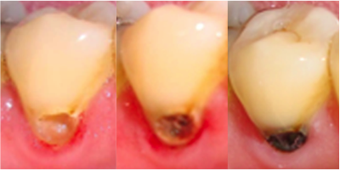
Benefits of receiving SDF:
- SDF can help stop tooth decay.
- SDF can help relieve sensitivity.
Risks related to SDF include, but are not limited to:
- The affected area will stain black permanently. Healthy tooth structure will not stain. Stained tooth structure can be replaced with a filling or a crown.
- Tooth-colored fillings and crowns may discolor if SDF is applied to them. Color changes on the surface can normally be polished off. The edge between a tooth and filling may keep the color.
- If accidentally applied to the skin or gums, a brown or white stain may appear that causes no harm, cannot be washed off, and will disappear in 1-3 weeks.
- You may notice a metallic taste. This will go away rapidly.
- If tooth decay is not arrested, the decay will progress. In that case the tooth will require further treatment, such repeat SDF, a filling or crown, root canal treatment, or extraction.
- These side effects may not include all of the possible situations reported by the manufacturer. If you notice other effects, please contact your dental provider.
- Every reasonable effort will be made to ensure the success of SDF treatment. There is a risk that the procedure will not stop the decay and no guarantee of success is granted or implied.
Alternatives to SDF, not limited to the following:
- No treatment, which may lead to continued deterioration of tooth structures and cosmetic appearance. Symptoms may increase in severity.
- Depending on the location and extent of the tooth decay, other treatment may include placement of fluoride varnish, a filling or crown, extraction, or referral for advanced treatment modalities.
I CERTIFY THAT I HAVE READ AND FULLY UNDERSTAND THIS DOCUMENT,
AND ALL MY QUESTIONS WERE ANSWERED:

________________________________(signature of patient) ___________________(date)
________________________________(signature of witness) ___________________(date)

